springfield primary school newsletter

Autumn term 2023
Teamwork Resilience Independence Creativity Kindness

Attendance News
The highest attendance for the week beginning 16 October was Y3 Turtles with 96.9%.
Week 7
2 Nov 2023

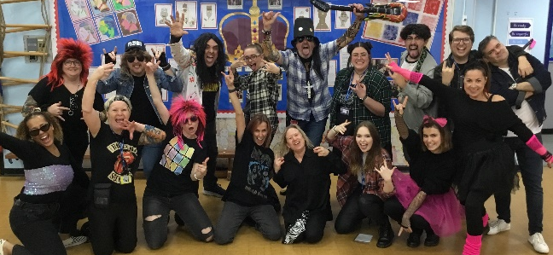
Rock Stars Day
We ended the half term with a bang and our annual Rock Stars Day. The children enjoyed a day of times tables activities and finished with a whole school concert of tables songs.
As so many parents have not completed the photo permission forms, it is hard to use photos of children at the moment.

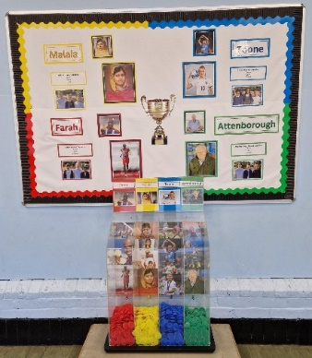
Houses
Our new collection box for house point tokens has arrived and looks great in the junior hall. Who will win overall at the end of the year?
Consent Forms
Please make sure you complete the consent form which has been sent out. If a form is not completed, it will be taken as NO consent given which will mean children do not take part in food tasting or individual or class photos etc.

Sports and Play Leaders
Our new Year 5 Play Leaders have completed their training. They will now be supporting other children at lunchtimes in the lunch hall and leading games and activities outside.
Our Sports Leaders received training this week led by staff from the local Sports Partnership and she was very complementary about our children and how hard they worked during the training.

Autumn Walk
After visiting the park to draw some maps, year 2 children did an autumn walk around the school grounds looking for signs of autumn.

Harvest
A big thank you to everyone who donated to our harvest appeal. It has all been delivered to the Chelmsford Food Bank and they were very grateful.

Flapjacks
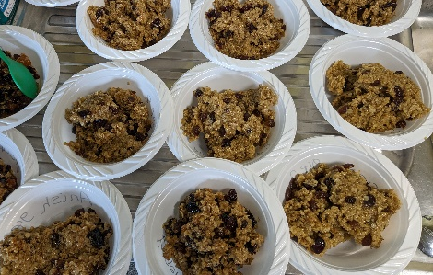
As part of writing instructions, year 4 children adapted a basic flapjack receipe. They tasted different dried fruits and in small groups wrote their own recipes then followed them to create flapjacks. There were varying degrees of success but still very tasty.

Dinner Menu w/b 6 November

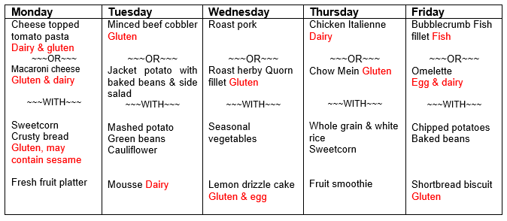

PTA News
Firework Themed Tuck shop tomorrow
Find us outside school at pick up time - the weather might be a bit mixed, so if we aren’t in the usual spots we will be somewhere in the playground or outside Y2 Badgers so keep an eye out for us! We will have sweets all 50p and some lovely homemade cakes for £1. Cash and cards accepted.

Quiz Night
Friday 10 November 6.30pm doors open for a 7pm start.
We have had a great response of teams for the quiz and have the last few tables available - £5 per person, teams between 4 to 8. Please e-mail the PTA to reserve a table springfieldprimarypta@gmail.com

Wreath Making Wednesday 6 December
Tickets cost £25 and includes everything needed to make a wreath and refreshments. Please email springfieldprimarypta@gmail.com to book a space.

Afternoon with Santa Wednesday 13 December.
Included in the ticket is crafts, activities, cookie decorating, a visit with Santa and a present for the children. The price is £7 per child and can be booked on: Payment details to the PTA are on the booking form. We have 3 slots 2-3pm, 3.15-4.15, 4.30-5.30 please let us know your preferred time slot. Spaces are limited so please book early!

Diary Dates Dates changed or added this week in red.

Autumn 2023
Fri 3 Nov | PTA Firework themed tuck shop | 3.15
Fri 10 Nov | PTA Quiz - parents only, email PTA team to register your team | 6.30
Tues 14 Nov | Y3&4 Roots to Food
Fri 17 Nov | Children in Need - non uniform and donate £1
Fri 24 Nov | Police workshops for all year groups  PTA Tuck shop & preloved Christmas jumper sale | 3.10
Fri 1 Dec | House assemblies - non uniform but wear house colours
Wed 6 Dec | PTA Wreath making evening. Ticketed event | 7-10pm
Fri 8 Dec | PTA non uniform day, suggested donation of £1
Mon 11 Dec | Y3&4 Carol concert for parents | 2pm & 6pm
Tues 12 Dec | EYFS & KS1 Nativity for parents | 10am & 2pm
Weds 13 Dec | Panto - Cinderella  Family afternoon with Father Christmas - ticketed event
Thurs 14 Dec | PTA gift sales - all gifts £2.50 cash only  Christmas dinner - non uniform, wear something festive
Fri 15 Dec | EYFS Christmas craft stay & play for EYFS parents/grandparents/carers  PTA gift sales - all gifts £2.50 cash only  PTA tuck shop | 1.45pm  3.10
Mon 18 Dec | Y5 Christmas play for parents | 2pm  6pm
Tues 19 Dec | Rock band concert for parents of children in rock bands  PTA tuck shop & raffle | 9.30
Weds 20 Dec | Break up | 3.10
Spring 2024
Thurs 4 Jan | School starts | 8.40
Tues 9 Jan | Y3 & Y5 dance sessions
Weds 10 Jan | Y1&Y4 dance sessions
Fri 26 Jan | Tuck shop
Tues 30 Jan | Junior choir at Young Voices at the O2
Tues 6 Feb | Y4 Superstar sports | 12.30-14.45
Fri 16 Feb | Tuck shop
Mon 19 Feb | Half term
Mon 26 Feb | Inset - school closed to children
Weds 28 Feb | Parents’ Evening | 3.45-5.45
Thurs 29 Feb | Parents’ Evening | 5pm-7.30
Thurs 7 Mar | World Book Day - non uniform / dress as book character
Fri 15 Mar | Red Nose day - non uniform and donate £1
Tues 19 Mar | The Two Johns - important session for parents | 6pm
Thurs 28 Mar | Break up  PTA Easter tuck shop | 3.10
Summer 2024
Mon 15 Apr | School starts | 8.40
Thurs 18 Apr | Y4&Y5 Ultimate Scooters
Fri 19 Apr | Y4&Y5 Ultimate Scooters
Fri 26 Apr | Tuck shop
Thurs 2 May | Provision Inset day - closed for voting TBC
Fri 3 May | EYFS & Y5 Road safety sessions
Mon 6 May | Bank Holiday
Thurs 16 May | PTA fun afternoon for EYFS, Y1&2
Fri 17 May | EYFS & Y5 Road safety sessions
Mon 20 May | Y6 dance sessions
Thurs 23 May | PTA disco for Y3,4,5 | tbc
Fri 24 May | PTA Tuck shop | 3.10
Tues 21 May | EYFS & Y2 dance sessions
Fri 24 May | Tuck shop
Mon 27 May | Half term
Tues 4 June | Y5 First aid sessions
Thurs 6 June | Y2 Mini Games | 9.30-11.45
12 - 14 June | Y6 Residential
Thurs 20 June | Sports Day | 9.30 KS2  1.30 EYFS & KS1
Thurs 12 July | Dance Afternoon for parents | 2pm
Thurs 27 June | Tuck shop
July | PTA Year 6 leavers party event -TBC
Mon 1 July | Inset - school closed to children
Thurs 18 July | Y6 Play for parents at Boswells Theatre | 6pm
Fri 19 July | PTA sponsored colour run
Sat 20 July | PTA Year 6 leavers party events | TBC
Tues 23 July | Children break up at 1.30 | 1.30
All dates subject to change

PE days
EYFS - Fri Y4 - Mon & Weds
Y1 - Mon & Weds Y5 - Tues & Fri
Y2 - Thurs & Fri Y6 Tigers - Thurs & Fri
Y3 - Mon & Weds Y6 Lions / Leopards - Tues & Thurs

