Springfield Primary School
Prospectus

2024

Welcome to Our School

Welcome to our school; I hope you will find this prospectus both interesting and informative and it will encourage you to come in and find out more; there’s nothing quite like seeing for yourself.
It is our fundamental belief that a school should reflect a sense of partnership, understanding and awareness that is shared by staff, governors, parents, the community and, of course, the children themselves. We hope we will have the opportunity to welcome you to share this process.

As a school we are committed to doing all we can to ensure our children enjoy and achieve during their time at Springfield Primary School and our curriculum:
- is enhanced through visitors and trips to give our children experiences and widen their outlook on life
- aims to deliver excellence in learning and teaching and expect all learners, children and adults, to be actively engaged in their own learning
- uses our school grounds to enhance learning at every opportunity
- is inclusive as we both support learners and encourage breadth and depth of learning, offering challenge and enjoyment
- ensures progression, being closely monitored and tracked to ensure the opportunity of attainment
- is cross curricular providing relevant links across subject areas but with clear, specific learning intentions
- celebrates diversity through units of work, assemblies, dance and visitors

We offer a range of activities and experiences as we want children to discover new interests and develop their talents.
Children thrive in an environment in which they are happy, challenged and secure in the knowledge they are safe and cared for, challenged to achieve their best, and happy in the knowledge they are each appreciated for their individuality and their achievements.

At Springfield we believe in a partnership with parents and carers and we acknowledge we will only be able to achieve the very best for your child if we work together. We have an open door policy so any concerns can be quickly addressed.

If you choose Springfield Primary for your child/children we will look forward to welcoming you and them to our school and, with your support, we will endeavour to provide a quality education in the all-important years that lie ahead.
Yours sincerely

Jacquelyn Pick
Headteacher

Springfield Primary is a happy school that very many pupils like attending.
Staff, like pupils and parents, are very proud of their school. Ofsted November 2021

School Address Forsythia Close
Chelmsford
Essex CM1 6XWS

Pupil Numbers 452

Telephone 01245 461077

Website www.springfield-pri.essex.sch.uk

Twitter @SpringfieldPri2

Head teacher: Mrs J Pick
Chair of Governors: Mrs D Knight

Learning Values

Our core learning values encourage our children to develop their team work, resilience independence, creativity and kindness. These values support the children in class, encourage them to be the best they can possibly be and equip them for life outside school.

At Springfield Primary School, we want our children to be happy and confident, be sociable and enthusiastic and feel listened to. We want them to feel safe, love learning and respect each other.

The children have the opportunity to earn a learning values sticker as and when they demonstrate them.

Our School

Springfield Primary School opened in September 2003, following an amalgamation of the infant and junior school which had been on the site since 1978.

The school is situated in a generous allocation of attractive grounds. The buildings are well maintained, there are good IT facilities, and the libraries and resource areas are well stocked. The grounds include a large playing field area, adventure playgrounds, environmental areas, an orchard and pond area, two separate hard play areas and an early years outdoor play area.

There is a kitchen on site providing cooked meals for the children. We have our own catering service which pays great attention to healthy eating with the cook planning the meals.

We maintain close links with the Springfield Stars, the pre-school on site and ensure a successful transition to The Boswells School or Beaulieu Park and other schools through a series of visits and other forms of liaison.

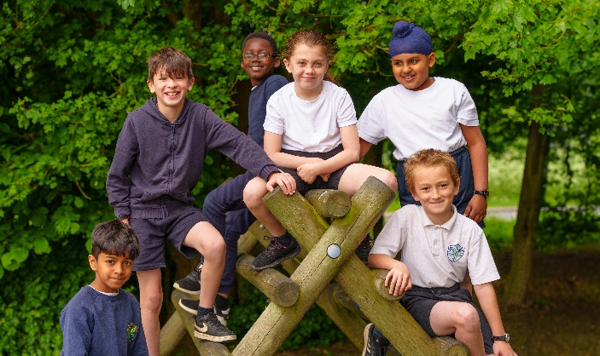

Roles

Our children are given opportunities to develop their leadership and teamwork skills in many different roles including being a
House Captain Play Leader Ambassador
Librarian School Council Rep Sports Leader

Y6 children are given the opportunity to apply to be a Springfield Ambassador. They are invited to complete an application form and are then invited to an interview. The Ambassadors support the younger children, show visitors and prospective staff round the school and respond to their questions. The Ambassadors are generally exemplary role models for their peers.

Plenty of pupils take advantage of the leadership opportunities and many sporting and artistic clubs on offer. Pupils are proud to run some of these clubs. Ofsted November 2021

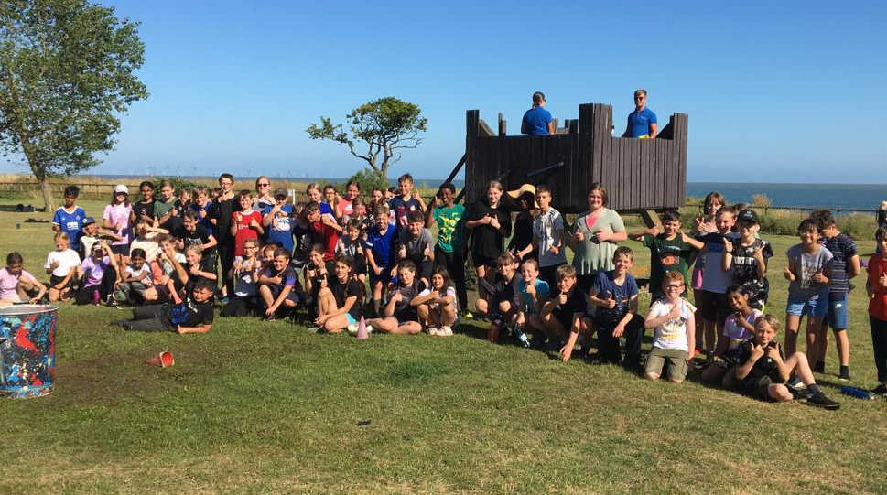
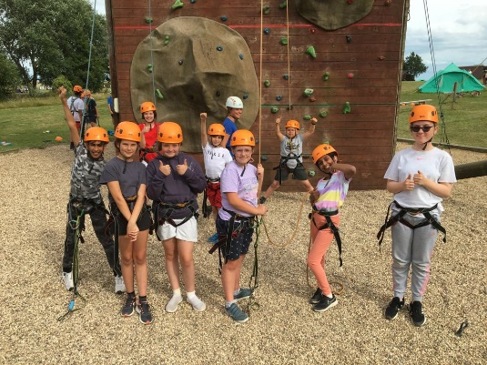

Viewing the School

We invite parents to visit, meet the headteacher and see the school in action. Our Springfield Ambassadors are keen to show visitors round and answer any questions so please contact the school office if you would like to arrange a visit.

Clubs

We run a wide range of after school activity clubs ranging from football, netball, volleyball, choir, cookery, tennis, dance and chess. There is a charge to parents for many of the clubs and they can be booked online.

Admissions
Published admission number for September 2024: 60 in each year group.

The Local Authority decides our admissions and all admission applications are made online and direct to Essex School Admissions. The closing date for applications is 15 January and you will receive an offer of a school place by April.

There is no guarantee of a place for children living in the priority admissions area. Places will be allocated using the following criteria in the order given:

- Looked After Children and previously looked after children
- Children with a sibling attending the school
- Children living in the priority admission area
- Remaining applications.

In the event of oversubscription within any of the above criteria, priority will be determined by straight line distance from home to school, those living closest being given the highest priority.
Exceptional medical circumstances (supported by medical evidence) may override the above.
All applications should be received by 15 January in the school year prior to entry. Priority is given to those in the catchment area.

Our staff may visit children in many local nurseries to meet the children before they come into school and in the summer term we hold transition sessions for both children and parents. The children spend some time in the EYFS classrooms and outside area so they can become familiar with the environment before they start with us in September.
Your first child starting school can be a hard time for parents; no question is too small so please ask if you have any concerns or questions. We will be there with you every step of the way.

Accessibility

All areas of our school are accessible for wheelchair users. As and when a child with a particular disability is admitted to our school, we will make every effort to ensure funding is made available for staff to receive any training required in that area of disability. Resources will be made available, subject to reasonable financial constraints, in order that the disabled child may access the curriculum.
Consideration is given to disabled access for any planned alterations to the school buildings or grounds. Our accessibility policy can be found on our website.

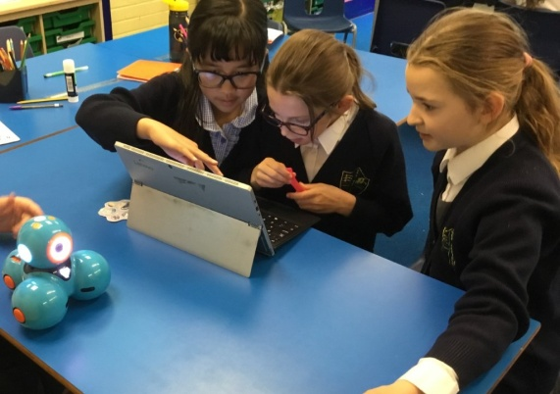

Lunchtime
Infants 12pm - 1pm
Juniors 12.10pm - 1.10pm

School Lunch
Dinner menus are notified on our website and in the newsletter emailed on a Thursday and payments are made online through ScoPay which parents can access through an app. The price for a hot lunch is £2 per day. All KS1 children are entitled to a free school meal under the Government’s Universal KS1 Free School Meal programme; these meals still need to be ordered as outlined above.

Free School Meal Entitlement
For children in Years 3-6, parents or guardians receiving Income Support, Jobseekers Allowance (Income Based), Income-Related Employment and Support Allowance or Child Tax Credit with an annual taxable income of less than £16,040 or the Pension Guarantee Credit can apply for Free School Meals. You will not be eligible for Free School Meals if you receive any amount of Working Tax Credit. Free School Meals can only be given on the basis of a completed and approved application and cannot be backdated.
Please make an application online at www.essex.gov.uk/educationawards.

Packed Lunches
Facilities are available for children to eat a healthy packed lunch brought from home. Please put sandwiches in a plastic container marked with the child’s name and class. All drinks must be in an unbreakable flask or container. No fizzy drinks, sweets or chocolates please.
We are a nut free school; please see our nut free policy on our website for further details.

Home for Lunch
If your child goes home for lunch, please collect them from the office at the start of their lunchtime and return them to school for the start of the afternoon session.

Mid-morning break
As part of the Government’s Fruit & Vegetable Scheme, all EYFS & KS1 children receive a piece of fruit or raw vegetable every morning. Children do not bring their own fruit. If you do not wish your child to participate in this scheme, or they have an allergy to fruits and vegetables, please contact the office.

If your junior aged child needs something to eat at playtime, they may bring fruit or a healthy snack.

Water
Please supply your child with a named, water bottle which can be kept and refilled in the classroom and is easily accessed throughout the day.
Other non-fizzy drinks are acceptable in a packed lunch.

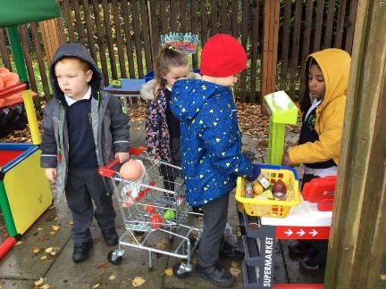
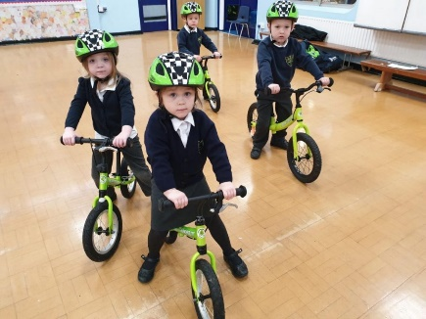
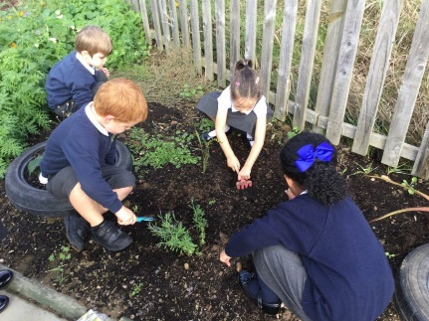

Classes
Our classes are named after endangered animals and each class has an allocated teacher who is responsible for the planning, delivery and assessment of all curriculum areas as well as pastoral care. The teachers plan together in year groups to ensure consistency across each year. Teaching Assistants work across all classes to support the teacher but also to work with children who require extra support whether as part of a specific need or a particular intervention.

Curriculum

Our curriculum:
- is enhanced through visitors and trips to give our children experiences and widen their outlook on life
- aims to deliver excellence in learning and teaching and strive to ensure all learners, children and adults, to be actively engaged in their own learning
- uses our school grounds to enhance learning at every opportunity
- is inclusive as we both support learners and encourage breadth and depth of learning, offering challenge and enjoyment
- ensures progression, being closely monitored and tracked to ensure the opportunity of attainment
- is cross curricular providing relevant links across subject areas but with clear, specific learning intentions
- celebrates diversity through units of work, assemblies, dance and visitors

Each of our curriculum units is planned to ensure the learning is exciting, purposeful and engaging for our learners.
We provide a nurturing environment where children can develop respect for themselves, each other, the wider community and the wider world. We support their interests, challenge their thinking and encourage them to take risks.

Homework

Children are also expected to read at home to an adult daily and also access Times Tables Rock Stars and Spellzone online.
These are tracked by class teachers but it is the responsibility of parents to ensure it is completed. On occasion there may be other tasks set

Sport

In PE, children are encouraged to discover through experience the range of movement of which the body is capable. In this way motor co-ordination and control is developed through body awareness, enabling children to be more imaginative and effective in a wide variety of situations. There are two halls, both of which are well equipped with both large and small apparatus and opportunities are provided for gymnastic activities and development of dance and games skills.

Children are given opportunities to take part in sporting events with local schools and also represent their school in a range of sporting competitions. We offer a variety of sports within the school curriculum including football, netball, rounders, athletics and the basic skills for cricket, hockey, basketball, rugby, swimming and health related fitness.

We have our own sports field, which has seasonal provision for one football pitch, two rounders pitches and a running circuit. There are two playgrounds, one with a netball court marked out and another with climbing apparatus for the younger children. We also have an adventure play area for the older children.

Life Skills

Our Life Skills curriculum helps to give children the knowledge, skills and understanding they need to lead confident, healthy, independent lives.
The children’s self-esteem is developed throughout their school life. Children are given the opportunity to reflect on their own thoughts, feelings and experiences, learning to deal with them in a positive way.
We encourage the children to interact appropriately with other children and adults and to form fulfilling relationships.
They are taught to treat each other with consideration and respect and to celebrate differences.
Children are taught about how to look after their bodies and keep themselves healthy.

The Life Skills curriculum covers key life skills appropriate to each age group including relationships and sex education. Please see the policy on our website for further information.

EYFS Curriculum

The children who join our EYFS classes benefit from having:
- a safe, caring environment with a large fenced outdoor area, well equipped for play and learning
- stimulating, attractive classrooms
- a good balance between child initiated experiences and direct teaching
- reading is taught through via a systematic synthetic phonics applying the Letters and Sounds guidance. We use Jolly Phonics resources and strategies to support this.
- children’s progress is recorded and measured in their learning journey

‘The teaching of phonics is good. Pupils love to read and use their phonics skills well.’
‘Owing to effective teaching and learning and a well-resourced setting, by the end of Reception Year, children make good progress from their different starting points. Children are confident, independent learners who are well prepared to move into Year 1.’
Ofsted January 2018

Provision for Children with Additional Needs

At Springfield Primary School we provide a caring environment within which all pupils can learn and develop to their full potential.
Teaching staff differentiate class work to ensure that all pupils have access to a broad and balanced curriculum. Some children will also have a One Plan which can be an individual educational programme. These are reviewed three times a year by class teachers and the Special Educational Needs Co-ordinator (SENCo) or SEND team in consultation with parents and children.

We work closely with Local Authority advisory services to ensure that pupils receive appropriate support for their specific areas of need. Parents are consulted and kept informed at all stages.

The school Special Educational Needs Policy complies with the Government’s Code of Practice (2015) and the Special Educational Needs and Disability Act (2018). Both the policy and the Code of Practice are available upon request for parents to inspect at school.

Leaders have high expectations for pupils’ personal development. Pupils learn about different beliefs, cultures and abilities. They speak with passion about the importance of treating everyone with fairness. Pupils’ behaviour demonstrates that very many do so. Relationships are based on respect. Ofsted November 2021

Attendance

Notification
Parents are responsible by law for ensuring the attendance of their children. Absence not authorised by the school has to be separately recorded on the child’s file and annual report. The school’s overall statistics are required to be reported to the Department for Education and Skills.

Please ensure that in cases of illness you inform the school, with a telephone call to the office by 8.30.

If we do not receive notification from a parent or guardian by 9.10am on the morning of absence, the school will telephone parents to confirm an absence. If we are unable to contact you, or the absence is other than for illness and not previously approved by the school, we are required to register the absence as unauthorised.
If we do not hear from you by 11am we will perform a welfare check which may lead to us informing the police.
Please notify us of medical appointments in advance by telephone or letter, together with lunchtime arrangements, if appropriate.

Lateness
The school day starts at 8.40am when children can begin to come into school. Registers are taken at 8.50am
Children arriving after 8.50am are required to come to school via the school office to sign in and provide a reason for their lateness which is recorded. We may send home ‘attendance letters’ in order to keep parents and carers informed.

At 9am the registers will be closed. If your child arrives after that time they will receive a mark that shows them to be on site, but this will not count as a present mark and it will mean they have an unauthorised absence for the morning session. This may mean that you could face the possibility of a Penalty Notice if the problem persists. If your child has a persistent late record you will be asked to meet with the Pastoral Lead or headteacher to discuss a way forward.

Leave of Absence
Authorisation for Leave of Absence may only be granted for:
Days of religious observance
Interviews for transfer to other schools
Participation in approved public performances
To attend an exceptional family occasion such as a wedding, funeral, graduation of close family members

Parents need to complete a Leave of Absence form for the above reasons, available from the school office, well in advance.
Leave of absence for family holidays will not be authorised.

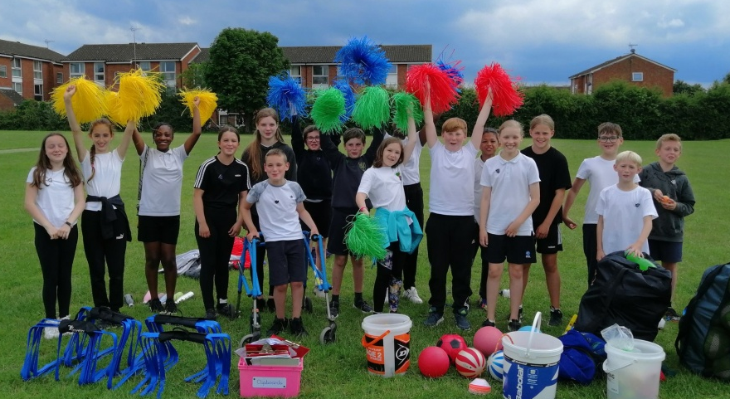

Health

Feeling Sick
If your child has been sick or has had diarrhoea during the night, please do not send him/her to school the next day, however much he/she wants to come. Children must stay at home for 48 hours following a bout of sickness and/or diarrhoea.

If a pupil has a serious or recurring medical problem this information must be included on the admissions form and the class teacher informed.

Routine medical appointments and dental check-ups should not be made within in school hours.

Accident and Emergencies
Before referral to a medical practitioner, every effort is made to contact parents. For this reason, it is essential that you inform the school of the home, work and mobile telephone numbers of all parents/guardians and any changes in these details.

Medicine
On the whole, if a child needs a prescribed medicine, they will probably need to be at home at the start of their illness. However, sometimes children requiring a long course of treatment, e.g. some antibiotics and, of course, asthma treatments, are able to return to school.
Staff at Springfield Primary School are only allowed to administer medicines:
- prescribed by a doctor, dentist, nurse prescriber or pharmacist prescriber
- that are in-date, labelled, provided in the original container as dispensed by a pharmacist and include prescriber’s instructions for administration, dosage and storage.

In order to avoid mistakes or confusion about medicines, they must be handed in to the school office clearly labelled with the child’s name, and the time and dosage the child requires. Medicines must not be given to children to keep in the classroom. A form of consent must be filled in.

We are unable to accept medicines that have been taken out of their original container or make changes to dosages on parental instructions.

Injuries or accidents in school are recorded on Medical Tracker. If a child has a minor head bump, parents may receive an email informing them of this.

Despite great vigilance on the part of our parents, occasionally a case of head lice is reported. As the children work and play closely together in school, the head lice have easy opportunities for head-to-head travel.
Every time you wash your child’s hair, please check it carefully with conditioner and a nit comb. Should you find it necessary, treatment lotions are available at the chemists.
We will notify all parents by email if headlice occur in their child’s class.

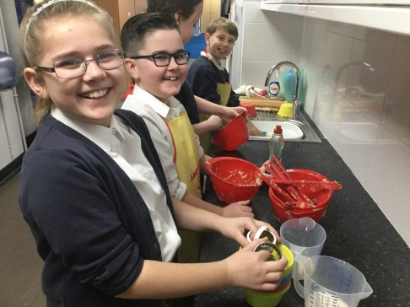
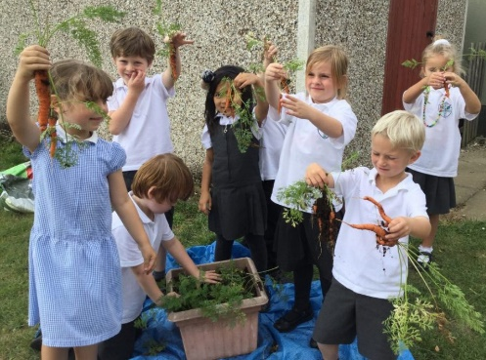

Before and After School Child Care

Our very successful breakfast and after school clubs have been running for 15 years. We have excellent experienced staff who also work within the school so are familiar friendly faces to both the children and their parents.
Our clubs are all about the children; they make suggestions for what activities they would like to do, what snacks they might like to try and how the clubs run on a daily basis.

Breakfast Club 8am - 8.40am £3.75 per session
After School Club 3.10pm - 6pm £10 per session

Manager Mrs Eve Churchett
Deputy Manager Mrs Charlotte Ibbott

If you wish to book your child into either club, please complete booking a booking form, contact the school office or email evechurchett@springfield-pri.essex.sch.uk Places are booked through the ScoPay app.
OFSTED Registration Number: EY300218

‘The breakfast club and after school club are very well run and ensure a great start and end to the school day. Leaders ensure that the most vulnerable families are well supported and encouraged to attend. Pupils leave the breakfast provision well prepared for the start of the school day and settle quickly into their classes.’
Ofsted January 2018

Residential Visits

The Year 6 children are given the opportunity to participate in a residential visit during the autumn term. This is a great experience for the children and allows them to get to know their new teachers and each other. In July 2024 the Y6 residential stayed at the Mersea Outdoor Centre. This residential is a great way to try out lots of different activities and challenges in a safe environment.

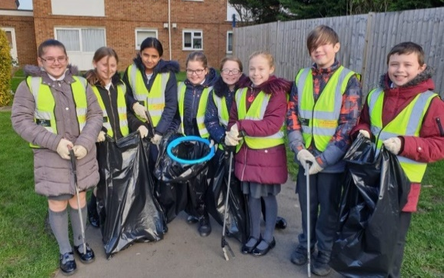
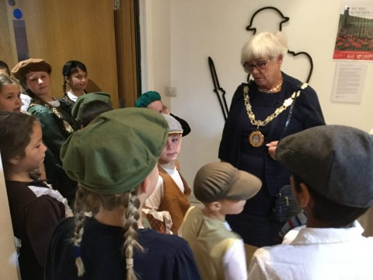

Pastoral Care

The prime responsibility for pastoral care lies with each teacher but, as this is a school where sharing and caring is important, we all share in responsibility for each other. We achieve this by involving teaching and non-teaching staff, parents, governors and, of course, the children themselves.
At the heart of our behaviour policy lies our belief in providing an appropriate example, in order to define values and set standards.
The school is a community in which behaviour is based upon mutual respect, courtesy and consideration for others. Pupils should feel confident within our school environment.

We encourage a family atmosphere whereby the older children care for the younger ones, for example, the Year 5 play leaders help out with play activities for the younger children at lunchtime.

Our Pastoral Lead Jill Kettley
As a Pastoral Lead at Springfield Primary School, I work with children and their families, to reduce barriers to learning and to help raise self-esteem, enabling the children to reach their full potential and to receive a full all-round education.
My work is to complement and support everyone involved in the teaching of the children, and to promote a safe, secure and happy environment in which the children can learn.
I work with the children on a one-to-one basis, in group work and within the class. I also run a club at lunchtimes, in our Butterfly Room, where children can drop in for a chat. I work closely with parents and carers and run groups helping us all to understand our children’s behaviours.

We are committed to supporting the wellbeing of both our staff and children. Please see our mental health and wellbeing policy.

We have a school council with an elected representative from each class from Y1 to Y6 which meets regularly to discuss school related issues.

Pupils told inspectors they are safe at school. They learn how to stay safe through personal, social and health education lessons and assemblies. They demonstrate a good understanding of internet safety.
Ofsted January 2018

Our first priority is your child’s welfare and, therefore, there may be occasions when our concern about your child means that we have to consult other agencies before we contact you. The procedures we follow have been laid down by the Essex Safeguarding Children Board.

Labelling Clothes

Please ensure that all clothes worn at school are clearly labelled with your child’s name. This ensures that any lost property can be dealt with quickly. We are unable to store unnamed articles of clothing.
Name labels can be bought from www.stikins.co.uk. Please quote School Fundraising Number 14003

Jewellery

For safety reasons jewellery may not be worn to school. This includes rings and necklaces. If children have pierced ears, they may only wear small studs. All earrings must be removed by the child for PE; this is a health and safety rule set by Essex County Council.

Uniform

All branded uniform is available either online or direct from One Stop School Gear based in Beehive Lane, Great Baddow.

Uniform
White blouse/shirt/plain white polo shirt or a school embroidered polo shirt
Grey skirt or pinafore
Grey tailored trousers or shorts (not legging type trousers)
Blue checked summer dress
Plain navy blue cardigan or school sweatshirt
Black, navy blue, grey or white socks
Black shoes or black trainers (not boots)
Flat sensible sandals with a back and closed toe may be worn in the summer

PE Kit
Navy blue or black shorts
Plain white t shirt
Plimsolls or trainers
Navy joggers and sweatshirt

It is useful to keep all named PE kit in a small drawstring bag which should be in school every day.
It is advisable for children to bring a hat in very hot weather.
No nail varnish is permitted.

Children come to school in their PE kit on a PE day which is advised to parents on our weekly newsletter.

Hair

We expect parents to send their child to school with a hairstyle that is appropriate and adds to their smart appearance. Extreme hairstyles are not encouraged. Long hair should be tied back.

Electronic Equipment & Toys etc

Children should not need to bring toys or equipment from home into school. If they do then it is the child’s responsibility to look after it; teachers will not take items for safekeeping. Children are not permitted to bring an iPad, camera, smart watch or any other electronic device to school.
If a child needs a mobile phone, it should be handed to the office, switched off, first thing in the morning. Under no circumstances are children permitted to film or take photos on the school premises. The headteacher reserves the right to view and delete the material on any phone, tablet or similar brought onto school premises by a child.

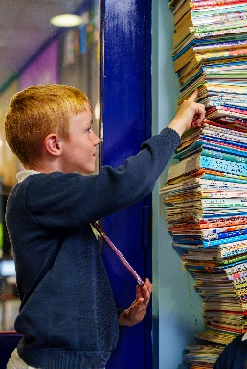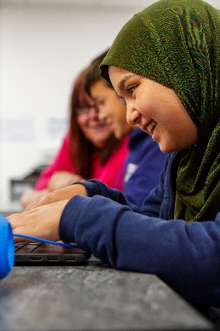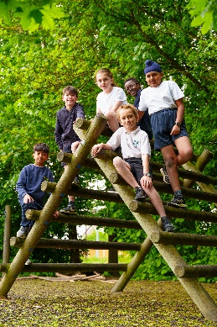

Parents’ Evenings

During the year there are a number of occasions when parents have the opportunity to meet their child’s class teacher. Formal parent consultation evenings are held in the autumn and spring terms. Parents are invited to book ten minute confidential appointments using our online system which is shared with parents before each Parents’ Evening. These appointments may be face to face or held remotely.

Teachers are readily available after school to discuss any minor concerns. If a longer time is needed an appointment can be arranged by the office staff.

The headteacher is also pleased to discuss matters with parents at any reasonable time. Should the head or deputy head not be available due to a prior commitment an appointment can be made through the office. We much prefer to address minor issues promptly before they develop into major ones, so please do not hesitate to contact us. We also like to be told when things are going particularly well!

PTA

We have a very supportive PTA Committee who work extremely hard to put on events in order to raise money for our children. This year alone they have helped us purchase mobile IT equipment, playground toys and equipment, reading books, library books and paid for a Christmas pantomime.

Our summer fete was a great success this year raising money all of which goes to help and support the children. The PTA hold regular discos and other events for the benefit of all children and support a trip or visitor for every year group.
Please come along if you would like to help or support PTA. All money raised goes to help and support our children.

Charging

Educational visits and visiting performers are an invaluable resource to bring alive aspects of a child’s study. These usually cost money and the school is not funded to provide for these. Parents are sometimes asked to make a contribution to cover the cost of these activities. However, no child is ever denied the opportunity to take part if his/her family is unable to contribute unless alternative activities are arranged in school, as happens for the Year 6 residential visit.

Where a parent elects to enrol their child for music tuition under the Authority’s Music School scheme, or the Music for Schools Foundation or Rock Steady Band, participation is only allowed where there is agreement to pay a standard fee.
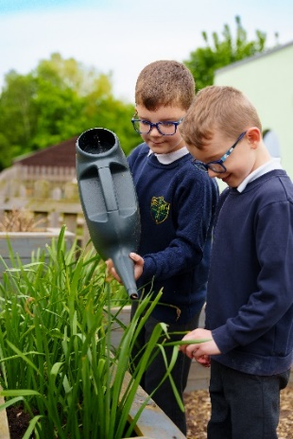
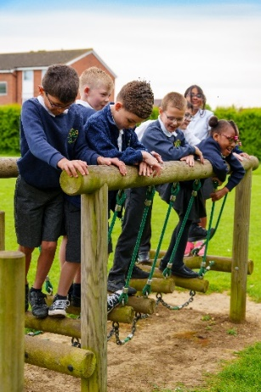

Complaints

The majority of concerns should be raised with your child’s class teacher. If the issue remains unresolved, please contact the headteacher or deputy headteacher.

In the case of complaint about the delivery of the National Curriculum or education and behaviour matters in general, please bring this first to the attention of your child’s class teacher.
If you are not satisfied with the outcome of this discussion or subsequent action, the headteacher, and later the governors, are available. The headteacher will either discuss the complaint with you privately or at a joint meeting.

A full copy of the Complaints Procedure, as recommended by the Local Authority, is available on request from the school office and on our website.

