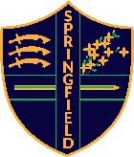
Y5 Home learning task log

summer term

Have you completed your home learning tasks this week? Ask your family to help you to keep track of them by ticking or signing this log.

The home learning tasks are checked in school every Wednesday and it is an expectation that your child completes the following each week. This log should not be returned to school, it is purely to help you to keep track of the home learning tasks at home.

 | 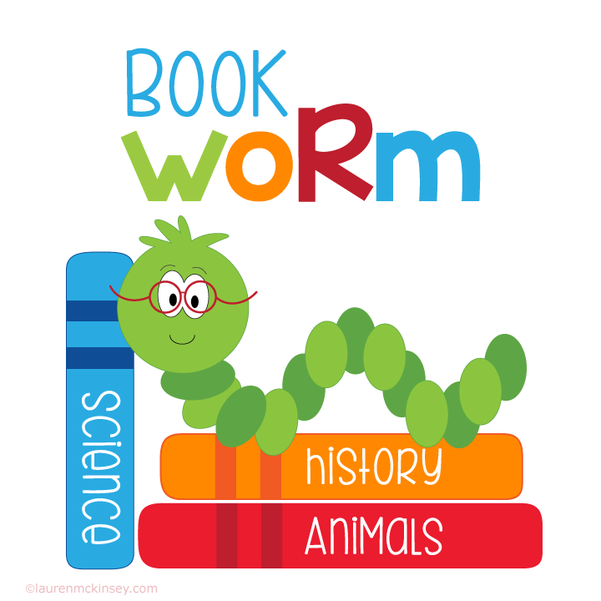  I have read 4 or more times at home (and written it in my diary) |   x10 minutes ‘Garage’  x10 minutes ‘Studio’ |   x20 minutes | 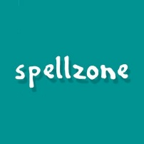  x3 tasks set by the teacher
w/c 13 April
w/c 20 April
w/c 27 April
w/c 4 May
w/c 11 May

 | I have read 4 or more times at home (and written it in my diary) | x10 minutes ‘Garage’  x10 minutes ‘Studio’ | x20 minutes | x3 tasks set by the teacher
w/c 1 June
w/c 8 June
w/c 15 June
w/c 22 June
w/c 29 June

w/c 6 July

